D.C DYES & PIGMENTS PVT. LTD. | FORTUNE CHEMICALS & ALLIED INDUSTRIES
User Guide
Inventory ERP — Phase 1 How to set up, receive stock, run production, sell and report
Item | Detail
Project | DC Dyes and Pigment — Inventory ERP (Phase 1)
Companies | D.C Dyes & Pigments Pvt. Ltd.; Fortune Chemicals & Allied Industries
For | Store, production, sales and management users
Version / Date | 1.0 — 07 Oct 2026
Note | Screens described here follow the Phase 1 prototype. Final screens may differ slightly in the production build.

Contents
1. About This Application
2. Getting Started (Login and Navigation)
3. Set Up the Masters
4. Bring in Stock (Inward)
5. Check Inventory and Ledger
6. Run a Production Entry
7. Sell Finished Goods
8. Reports and Exports
9. Using Filters
10. Quick-start Checklist
11. Troubleshooting and FAQ
Appendix A. Application Flowchart
Appendix B. Production Entry Flowchart
Appendix C. Glossary

1. About This Application
The Inventory ERP tracks raw materials and packaging from the day they arrive, through production, to finished goods and sale. Every quantity is tracked by batch, so you always know what you have, where it came from and what it cost.
What you can do:
- Receive raw material and packaging stock in batches
- See stock batch-wise, supplier-wise and product-wise, with a full ledger
- Run production using lot-based formulas, with automatic material calculation and costing
- Compare input with output to see evaporation and wastage
- Keep finished goods stock and record sales with profit or loss
- Export reports to Excel and PDF
Not in this phase (shown greyed out in the menu): QC Management, Live Production Tracking and Dispatch.
2. Getting Started
2.1 Log in
- Open the application. The first screen asks you to select your company.
- Click D.C Dyes & Pigments Pvt. Ltd. or Fortune Chemicals & Allied Industries.
- Type your username and password, then click Login. To pick a different company, click "Change company".
Each company has its own separate data. Whatever you see after login belongs only to the company you chose.
2.2 Finding your way around
Area | What it is
Top bar | Shows the active company and your user name, with Logout
Sidebar (left) | Menu in groups: Masters, Inward, Inventory, Production, Sales, Reports. Click an item to open it
Phase 2 items | QC, Live Production Tracking and Dispatch are greyed out with a "Phase 2" tag. Clicking shows a message that they are not built yet
Dashboard | Opening summary. A good place to glance at after you have entered data
2.3 Log out
Click Logout in the top bar. You return to the company-selection screen. Log out before handing the computer to someone who works for the other company.
3. Set Up the Masters
Do this once, in the order below. Later masters use earlier ones. The Masters group in the sidebar holds all of them.
3.1 Category Master and Unit Master
These feed the dropdowns in other forms. Click Add Category or Add Unit, type the name and save. The standard categories (Minerals, Dyes, Pigments and so on) and units (kg, g, l, m, pcs) are already there, so add only what is missing.
3.2 Supplier Master
- Click Add Supplier.
- Fill in name, contact, phone, city and GSTIN.
- Under Materials Supplied, pick a raw material from the dropdown; it appears as a chip. Repeat for each material the supplier provides.
- If a material is not listed, add it in the Raw Material Master first, then come back.
- Use the filters above the list (name, contact or code, city, materials supplied) to find a supplier.
3.3 Raw Material Master
- Click Add Raw Material.
- Enter name, grade, category, unit and minimum stock.
- Enter a Material Code of 2–5 letters or numbers (for example UMB). It is mandatory and becomes part of every batch ID for this material.
- Save. Once stock has been received against a material, a lock icon appears on its code. You can still edit the other fields, but not the code.
3.4 Packaging Material Master
- Click Add Packaging Material.
- Enter name, Item Code (same rule as the material code), size and brand.
- Choose Stock Unit and Usage Unit from the Unit Master.
- Set the Universal toggle. No (default): select the product this item belongs to. Yes: the product field is hidden and the item can be used for any product, such as cartons or containers.
- Fill Pack Capacity (kg) only if this item is the smallest unit in a packing chain; otherwise leave it blank.
3.5 Packaging Formula Master
This defines how packaging nests together, for example a 1 kg inner packet packed into a 25 kg bag.
- Click Add Formula.
- Choose the Base Item (the smaller unit), the Parent Item (what it packs into) and the Quantity per Parent (for example 25).
- Give a short label such as "25kg Bag via 1kg Inner".
- For a deeper chain (packet, carton, container), add another record whose Base Item is the parent from the first one. The app links them automatically.
- You can add several formulas for the same base item to show different ways of packing it.
3.6 Product Master
Click Add Product / Grade. Enter grade code, name, category and the Standard Lot Qty, which is how much one production lot makes.
3.7 Lot-based BOM / Formula
This is the raw material recipe per lot. Do not confuse it with the Packaging Formula Master above.
- Click Add Formula at the top, or New Formula on a product card.
- Select the product and give the formula a name, for example "Standard Formula".
- Add raw material lines with the quantity needed per lot.
- A product can have several formulas. Mark one as Default; Production Entry uses the default unless you choose another.
- Use the Box View / Table View switch at the top. Box View shows one card per grade. Table View lists every line in one table that you can filter by grade, formula name, default only and raw material, and clear with Reset Filters.
3.8 Customer Master
Add each customer with name, contact and GSTIN before recording a sale.
4. Bring in Stock (Inward)
4.1 Raw Material Inward
- Open Raw Material Inward and click to add a new inward.
- Pick the Supplier, the Raw Material and the Date.
- Enter batch lines: number of bags × weight per bag × rate. Add as many lines as you received (for example five 200 kg batches under one inward).
- The Batch ID appears automatically (for example RM-UMB-0001). You never type it. The Inward ID (INW-XXXX) is also automatic.
- Click Post Inward. Stock updates at once; check it under RM Inventory & Ledger.
The history table below the form can be filtered by material, supplier and date range.
4.2 Packaging Inward
Works the same way: pick the packaging item and date, enter quantity, rate and grade for each batch line, and post. Batch IDs look like PKG-HDPE-0001.
5. Check Inventory and Ledger
5.1 RM Inventory & Ledger
Tab | What you see
Batch-wise Stock | Every batch with supplier, rate, received quantity and balance
Inventory Ledger | Every IN and OUT movement with date, type and batch
Product-wise Report | Grouped by material, then supplier, then grade, with quantity and batches
5.2 Packaging Inventory
Tab | What you see
Hierarchy | Drill-down from Item to Product, Size, Brand, Supplier and Grade
Batch-wise Stock | Each packaging batch and its balance
Ledger | Packaging IN and OUT movements
Stock by Chain Level | Pick a packing configuration and a "view as" unit to see equivalent quantities across the chain, for example how many cartons' worth of loose packets you still have
6. Run a Production Entry
Production Entry is a step-by-step wizard. Follow the steps in order; the screen shows which step you are on. The full flowchart is in Appendix B.
Step | Name | What to do
1 | Select Grade | Pick the product. If it has more than one formula, pick the formula to use.
2 | No. of Lots | Enter how many lots you are running. The expected output is shown.
3 | Required Materials | The app calculates raw material = formula quantity per lot × lots. If a material shows "Insufficient", click Go to Raw Material Inward. It opens Inward with that material selected; after posting stock, you return to this same step. You can also add Add-on Materials (for example water or methanol) from the raw material list, entered per lot.
4 | Consume & Cost | Shows raw material cost and rate per kg. Under Estimated Packaging Material, pick Item > Size > Brand > Configuration; every level of the packing chain (inner packets and outer bag, for instance) appears with editable quantities and available stock. Actual packaging consumption can be logged below.
5 | Actual Output | Enter the weighed output.
6 | Reconcile & Finish | Review input versus output, wastage %, total cost and cost per kg. Click Create Finished Product Batch to post.
When you post, raw material and packaging stock are deducted, ledger entries are written, and a new Finished Goods batch is created.
7. Sell Finished Goods
7.1 Finished Goods Stock
Lists every finished goods batch with Produced, Sold and Available quantity and status: Unsold, Partially Sold or Fully Sold.
7.2 Sales Entry
- Pick the finished goods batch and the customer.
- Enter the quantity sold. It is checked against what is left on that batch.
- Cost price is filled in automatically. Enter the actual sale rate.
- Switch GST on or off and enter the percentage if needed. Sale value, GST, total and profit or loss update as you type.
- Save. You can sell the same batch to several customers in parts; the available quantity keeps reducing.
7.3 Sales Report
Shows product-wise, customer-wise and date-wise totals with GST and profit or loss. Excel and PDF export are available.
8. Reports and Exports
Open Reports & Exports. Available reports: Raw Material, Finished Product, Production, Packaging and Sales. Each has filters and Export buttons.
Export | How it works
Excel | Click Export Excel. A file downloads that opens in Excel (in the prototype it is a CSV file)
PDF | Click Export PDF. The print dialog opens; choose "Save as PDF" as the printer
9. Using Filters
Most lists have a filter bar above the table. Filters combine, so choosing a material and a supplier shows only rows matching both. Clear the fields to see everything again.
Screen | Available filters
Raw Material Inward history | Material, supplier, from-date, to-date
RM Batch-wise Stock | Material, supplier, batch search
RM Ledger | Material, type (IN / OUT), date range, batch search
Packaging Inventory | Item, batch search, type, date range
Supplier Master | Name / contact / code, city, materials supplied
Formula Table View | Grade, formula name, default only, raw material, with Reset Filters
10. Quick-start Checklist
A first run-through that touches almost every screen:
- Log in and choose your company.
- Add one supplier, one raw material and one packaging item (and a packaging formula if you pack in layers).
- Add one product with a lot quantity and a formula.
- Post a Raw Material Inward and a Packaging Inward.
- Run a Production Entry from step 1 to step 6.
- Check RM Inventory & Ledger and Finished Goods Stock.
- Add a customer and record a sale.
- Open a report and export it to Excel and PDF.
11. Troubleshooting and FAQ
Problem | What to do
Cannot type a batch number | Batch IDs are automatic by design
Cannot change the material code | The code locks after stock is received; other fields can still be edited
Production shows "Insufficient" | Use Go to Raw Material Inward, post the missing stock, and you return to the same step
A material is missing in a supplier or formula form | Add it in the Raw Material Master first
A product has two formulas and the wrong one is used | Set the correct formula as Default, or choose it in step 1 of Production Entry
Cannot sell more than a batch holds | Sales quantity is limited to the Available quantity on that batch
I do not see the other company's data | Correct: each company is separate. Log out and choose the other company
My data vanished after refreshing | The prototype keeps data in memory only. The production build will save data permanently
QC, Live Tracking or Dispatch will not open | They are Phase 2 features

Appendix A. Application Flowchart
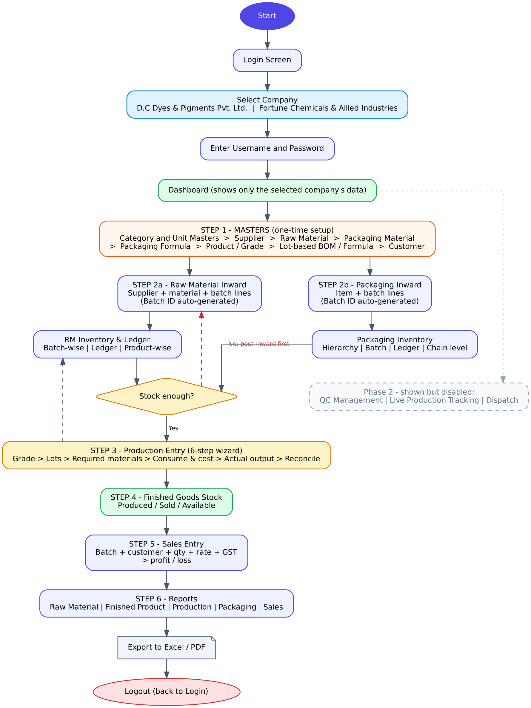
Complete application flow, login to logout

Appendix B. Production Entry Flowchart
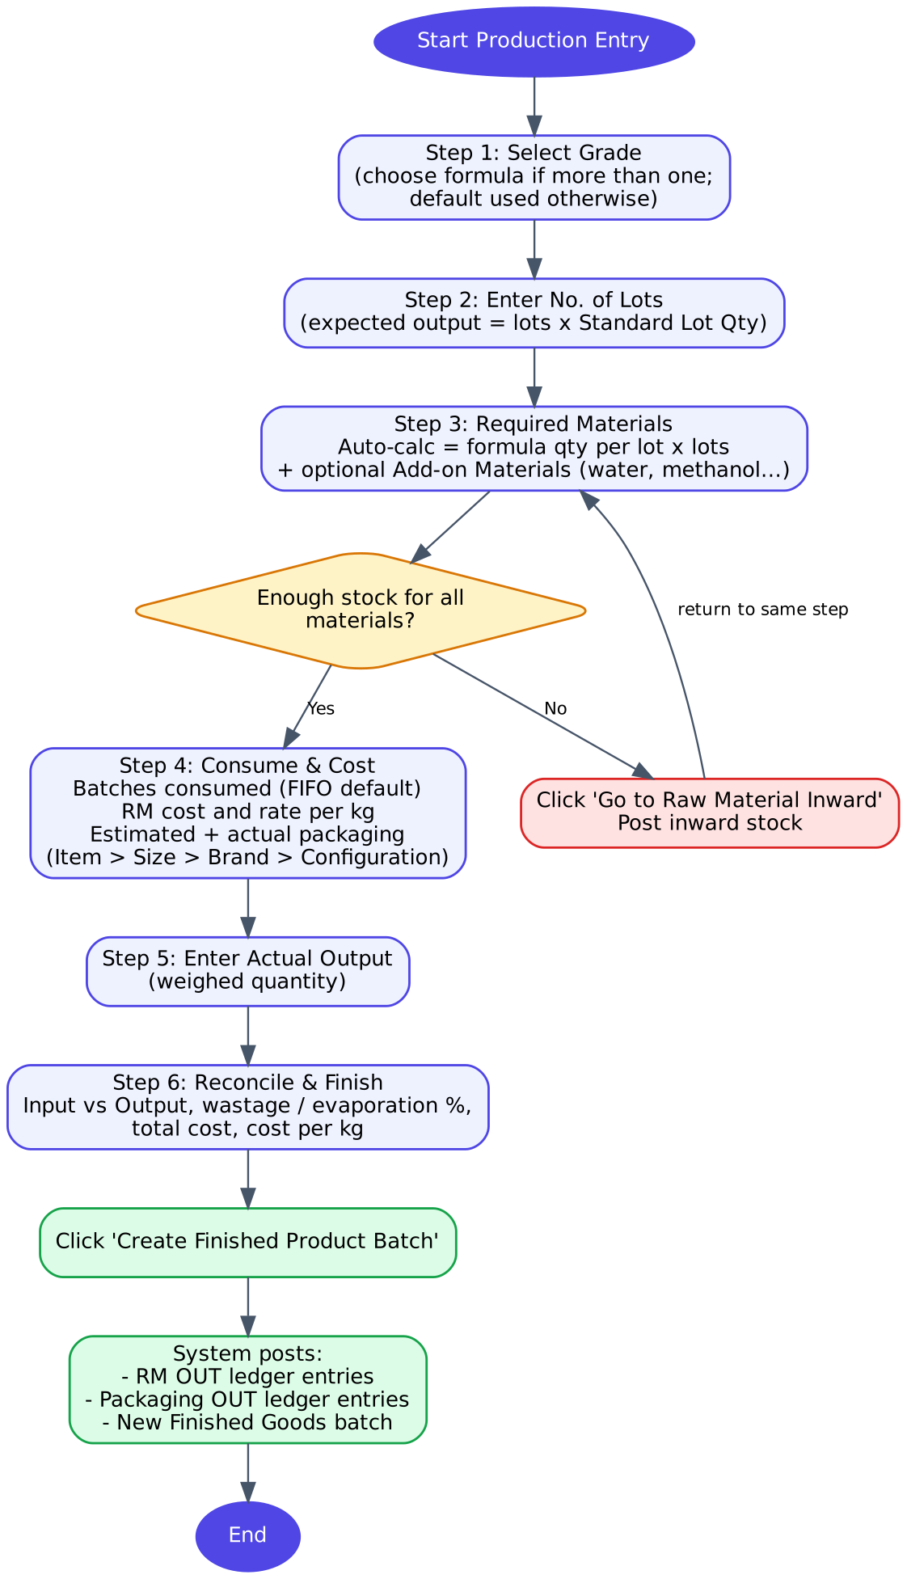
Production Entry, six steps

Appendix C. Glossary
Term | Meaning
Batch | A received or produced quantity with its own ID, rate and source
Inward | Recording stock that has arrived, possibly as several batches
Ledger | The history of every stock IN and OUT
Lot | One standard production run
Standard Lot Qty | Quantity one lot of a product is expected to make
BOM / Formula | Raw materials and quantities needed per lot
Add-on material | Extra material (such as water) added during production, outside the formula
Reconciliation | Comparing input consumed with output produced
Evaporation / Wastage | Input minus output, shown as a percentage
Universal (packaging) | An item usable for any product
FG | Finished Goods
FIFO | First in, first out: oldest batch is used first

